Department of Computer Science, CUI Lahore
 | Assignment 1
Name: | Section: | Course Title: Semantic Web | Date:
Reg.#: | Instructor: Sana Rizwan | Marks: 5 | Class/Batch:

Question:
Create XML tree by the help of XML coding given below:

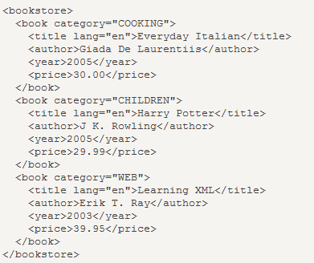

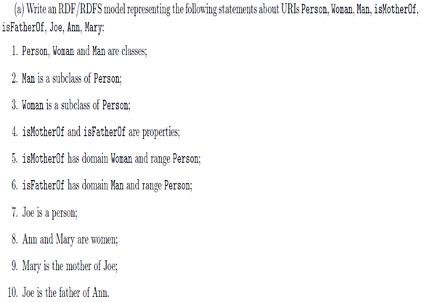

a) Write RDF/RDFS data model for the above given statement.
b) Show the RDF Triple model for the said scenario.
c) Draw the RDF/XML Graph showing the relations.

